Supervised Machine Learning

Supervised learning is the types of machine learning in which machines are trained using well "labelled" training data, and on basis of that data, machines predict the output. The labelled data means some input data is already tagged with the correct output.

In supervised learning, the training data provided to the machines work as the supervisor that teaches the machines to predict the output correctly. It applies the same concept as a student learns in the supervision of the teacher.

Supervised learning is a process of providing input data as well as correct output data to the machine learning model. The aim of a supervised learning algorithm is to **find a mapping function to map the input variable(x) with the output variable(y)**.

In the real-world, supervised learning can be used for **Risk Assessment, Image classification, Fraud Detection, spam filtering**, etc.

How Supervised Learning Works?

In supervised learning, models are trained using labelled dataset, where the model learns about each type of data. Once the training process is completed, the model is tested on the basis of test data (a subset of the training set), and then it predicts the output.

The working of Supervised learning can be easily understood by the below example and diagram:

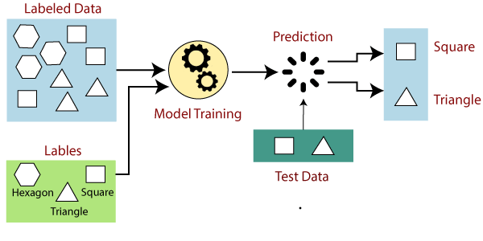

Suppose we have a dataset of different types of shapes which includes square, rectangle, triangle, and Polygon. Now the first step is that we need to train the model for each shape.

* If the given shape has four sides, and all the sides are equal, then it will be labelled as a **Square**.
* If the given shape has three sides, then it will be labelled as a **triangle**.
* If the given shape has six equal sides then it will be labelled as **hexagon**.

Now, after training, we test our model using the test set, and the task of the model is to identify the shape.

The machine is already trained on all types of shapes, and when it finds a new shape, it classifies the shape on the bases of a number of sides, and predicts the output.

Steps Involved in Supervised Learning:

* First Determine the type of training dataset
* Collect/Gather the labelled training data.
* Split the training dataset into training **dataset, test dataset, and validation dataset**.
* Determine the input features of the training dataset, which should have enough knowledge so that the model can accurately predict the output.
* Determine the suitable algorithm for the model, such as support vector machine, decision tree, etc.
* Execute the algorithm on the training dataset. Sometimes we need validation sets as the control parameters, which are the subset of training datasets.
* Evaluate the accuracy of the model by providing the test set. If the model predicts the correct output, which means our model is accurate.

Types of supervised Machine learning Algorithms:

Supervised learning can be further divided into two types of problems:

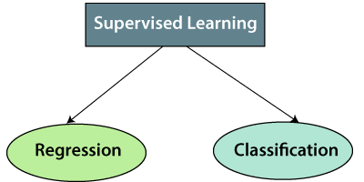

**1. Regression**

Regression algorithms are used if there is a relationship between the input variable and the output variable. It is used for the prediction of continuous variables, such as Weather forecasting, Market Trends, etc. Below are some popular Regression algorithms which come under supervised learning:

* Linear Regression
* Regression Trees
* Non-Linear Regression
* Bayesian Linear Regression
* Polynomial Regression

**2. Classification**

Classification algorithms are used when the output variable is categorical, which means there are two classes such as Yes-No, Male-Female, True-false, etc.

Spam Filtering,

* Random Forest
* Decision Trees
* Logistic Regression
* Support vector Machines

Note: We will discuss these algorithms in detail in later chapters.

Advantages of Supervised learning:

* With the help of supervised learning, the model can predict the output on the basis of prior experiences.
* In supervised learning, we can have an exact idea about the classes of objects.
* Supervised learning model helps us to solve various real-world problems such as **fraud detection, spam filtering**, etc.

Disadvantages of supervised learning:

* Supervised learning models are not suitable for handling the complex tasks.
* Supervised learning cannot predict the correct output if the test data is different from the training dataset.
* Training required lots of computation times.
* In supervised learning, we need enough knowledge about the classes of object.

Unsupervised Machine Learning

In the previous topic, we learned supervised machine learning in which models are trained using labeled data under the supervision of training data. But there may be many cases in which we do not have labeled data and need to find the hidden patterns from the given dataset. So, to solve such types of cases in machine learning, we need unsupervised learning techniques.

What is Unsupervised Learning?

As the name suggests, unsupervised learning is a machine learning technique in which models are not supervised using training dataset. Instead, models itself find the hidden patterns and insights from the given data. It can be compared to learning which takes place in the human brain while learning new things. It can be defined as:

*Unsupervised learning is a type of machine learning in which models are trained using unlabeled dataset and are allowed to act on that data without any supervision.*

Unsupervised learning cannot be directly applied to a regression or classification problem because unlike supervised learning, we have the input data but no corresponding output data. The goal of unsupervised learning is to **find the underlying structure of dataset, group that data according to similarities, and represent that dataset in a compressed format**.

**Example:** Suppose the unsupervised learning algorithm is given an input dataset containing images of different types of cats and dogs. The algorithm is never trained upon the given dataset, which means it does not have any idea about the features of the dataset. The task of the unsupervised learning algorithm is to identify the image features on their own. Unsupervised learning algorithm will perform this task by clustering the image dataset into the groups according to similarities between images.

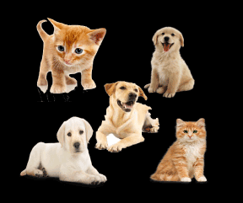

Why use Unsupervised Learning?

Below are some main reasons which describe the importance of Unsupervised Learning:

* Unsupervised learning is helpful for finding useful insights from the data.
* Unsupervised learning is much similar as a human learns to think by their own experiences, which makes it closer to the real AI.
* Unsupervised learning works on unlabeled and uncategorized data which make unsupervised learning more important.
* In real-world, we do not always have input data with the corresponding output so to solve such cases, we need unsupervised learning.

Working of Unsupervised Learning

Working of unsupervised learning can be understood by the below diagram:

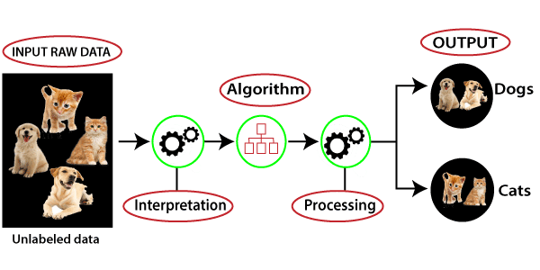

Here, we have taken an unlabeled input data, which means it is not categorized and corresponding outputs are also not given. Now, this unlabeled input data is fed to the machine learning model in order to train it. Firstly, it will interpret the raw data to find the hidden patterns from the data and then will apply suitable algorithms such as k-means clustering, Decision tree, etc.

Once it applies the suitable algorithm, the algorithm divides the data objects into groups according to the similarities and difference between the objects.

Types of Unsupervised Learning Algorithm:

The unsupervised learning algorithm can be further categorized into two types of problems:

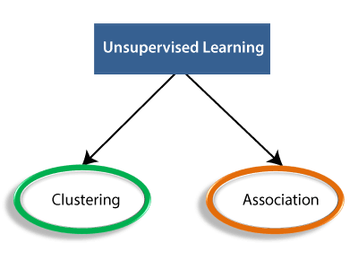

* **Clustering**: Clustering is a method of grouping the objects into clusters such that objects with most similarities remains into a group and has less or no similarities with the objects of another group. Cluster analysis finds the commonalities between the data objects and categorizes them as per the presence and absence of those commonalities.
* **Association**: An association rule is an unsupervised learning method which is used for finding the relationships between variables in the large database. It determines the set of items that occurs together in the dataset. Association rule makes marketing strategy more effective. Such as people who buy X item (suppose a bread) are also tend to purchase Y (Butter/Jam) item. A typical example of Association rule is Market Basket Analysis.

Note: We will learn these algorithms in later chapters.

Unsupervised Learning algorithms:

Below is the list of some popular unsupervised learning algorithms:

* **K-means clustering**
* **KNN (k-nearest neighbors)**
* **Hierarchal clustering**
* **Anomaly detection**
* **Neural Networks**
* **Principle Component Analysis**
* **Independent Component Analysis**
* **Apriori algorithm**
* **Singular value decomposition**

Advantages of Unsupervised Learning

* Unsupervised learning is used for more complex tasks as compared to supervised learning because, in unsupervised learning, we don't have labeled input data.
* Unsupervised learning is preferable as it is easy to get unlabeled data in comparison to labeled data.

Disadvantages of Unsupervised Learning

* Unsupervised learning is intrinsically more difficult than supervised learning as it does not have corresponding output.
* The result of the unsupervised learning algorithm might be less accurate as input data is not labeled, and algorithms do not know the exact output in advance.

# Difference between Supervised and Unsupervised Learning

Supervised and Unsupervised learning are the two techniques of machine learning. But both the techniques are used in different scenarios and with different datasets. Below the explanation of both learning methods along with their difference table is given.

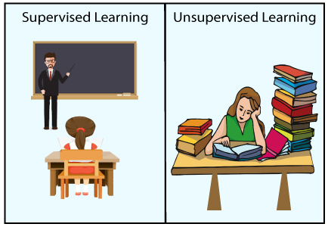

## Supervised Machine Learning:

Supervised learning is a machine learning method in which models are trained using labeled data. In supervised learning, models need to find the mapping function to map the input variable (X) with the output variable (Y).

Supervised Machine learning

Supervised learning needs supervision to train the model, which is similar to as a student learns things in the presence of a teacher. Supervised learning can be used for two types of problems: **Classification** and **Regression**.

How to find Nth Highest Salary in SQL

**Example:** Suppose we have an image of different types of fruits. The task of our supervised learning model is to identify the fruits and classify them accordingly. So to identify the image in supervised learning, we will give the input data as well as output for that, which means we will train the model by the shape, size, color, and taste of each fruit. Once the training is completed, we will test the model by giving the new set of fruit. The model will identify the fruit and predict the output using a suitable algorithm.

## Unsupervised Machine Learning:

Unsupervised learning is another machine learning method in which patterns inferred from the unlabeled input data. The goal of unsupervised learning is to find the structure and patterns from the input data. Unsupervised learning does not need any supervision. Instead, it finds patterns from the data by its own.

Unsupervised learning can be used for two types of problems: **Clustering** and **Association**.

**Example:** To understand the unsupervised learning, we will use the example given above. So unlike supervised learning, here we will not provide any supervision to the model. We will just provide the input dataset to the model and allow the model to find the patterns from the data. With the help of a suitable algorithm, the model will train itself and divide the fruits into different groups according to the most similar features between them.

The main differences between Supervised and Unsupervised learning are given below:

|  |  |
| --- | --- |
| **Supervised Learning** | **Unsupervised Learning** |
| Supervised learning algorithms are trained using labeled data. | Unsupervised learning algorithms are trained using unlabeled data. |
| Supervised learning model takes direct feedback to check if it is predicting correct output or not. | Unsupervised learning model does not take any feedback. |
| Supervised learning model predicts the output. | Unsupervised learning model finds the hidden patterns in data. |
| In supervised learning, input data is provided to the model along with the output. | In unsupervised learning, only input data is provided to the model. |
| The goal of supervised learning is to train the model so that it can predict the output when it is given new data. | The goal of unsupervised learning is to find the hidden patterns and useful insights from the unknown dataset. |
| Supervised learning needs supervision to train the model. | Unsupervised learning does not need any supervision to train the model. |
| Supervised learning can be categorized in **Classification** and **Regression** problems. | Unsupervised Learning can be classified in **Clustering** and **Associations** problems. |
| Supervised learning can be used for those cases where we know the input as well as corresponding outputs. | Unsupervised learning can be used for those cases where we have only input data and no corresponding output data. |
| Supervised learning model produces an accurate result. | Unsupervised learning model may give less accurate result as compared to supervised learning. |
| Supervised learning is not close to true Artificial intelligence as in this, we first train the model for each data, and then only it can predict the correct output. | Unsupervised learning is more close to the true Artificial Intelligence as it learns similarly as a child learns daily routine things by his experiences. |
| It includes various algorithms such as Linear Regression, Logistic Regression, Support Vector Machine, Multi-class Classification, Decision tree, Bayesian Logic, etc. | It includes various algorithms such as Cluster |